Quiz # 3
Web Programming - Section (B)
Total Marks: 10 Time: 40 minutes

- What is dependency injection. Explain the steps to remove it from MVC project with the help of an example (5 marks)
Make interface in models of student class, download and install ninject web common then bind interface with class
- Make the following view using html helpers (5 marks)

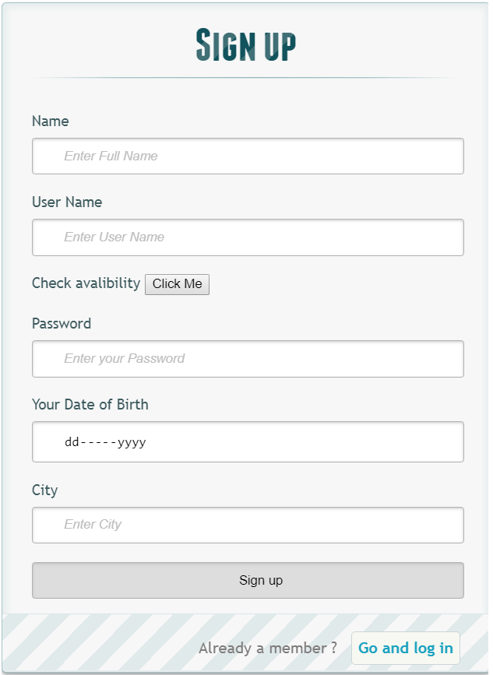

@using (Html.BeginForm("signUp","Home",FormMethod.Post)){
<h1> Sign up </h1>
<p>
@Html.Label("","Name")
@Html.TextBoxFor(m => m.fname, new {placeholder="Enter Full Name" , required="required"})
@Html.ValidationMessageFor(m =>m.fname)
</p>
<p>
@Html.Label("","User Name")
@Html.TextBoxFor(m => m.uname, new {placeholder="Enter User Name" , required="required"})
@Html.ValidationMessageFor(m =>m.uname)
</p>
<p>
@Html.Label("","Check avalibility")
<button id="username_check" name="username_check" onclick="f1()"> Click Me </button>
</p>
<p>
@Html.Label("","Password")
@Html.TextBoxFor(m => m.pwd, new {placeholder="Enter your Password" , required="required" })
@Html.ValidationMessageFor(m =>m.pwd)
</p>
<p>
@Html.Label("","Your Date of Birth")
<input id="userdob" name="dob" required="required" type="date" />
</p>
<p>
@Html.Label("", "City")
@Html.TextBoxFor(m => m.city, new {placeholder="Enter City" , required="required"})
@Html.ValidationMessageFor(m =>m.city)
</p>
<p >
<input type="submit" value="Sign up"/>
</p>
<p class="change_link">
Already a member ? <a href="#tologin" class="to_register"> Go and log in </a>
</p>
}

